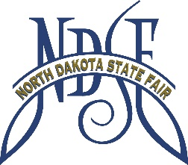

4-H Horse Only
July 17-July 25, 2026
This form is to be used for exhibitors entering in 4-H HORSE SHOW ONLY.
Anyone entering in 4-H AND Open Class MUST use the ND State Fair
entry form for vehicle and gate passes.
Mail to: ND State Fair – PO Box 1796 – Minot ND 58702

Name: Phone #:

Address:

Email:

Extension Agent Signature:

Horse Trailer Pass:
Mark Days Needed
July 19 July 20 July 21 July 22

Number of days x $10.00/day
Trailer Pass Total $

Stalling (stalls are no charge for Monday, Tuesday or Wednesday ONLY):
Number of stalls = ______ Tack Stall: _____YES / _____NO
*Tack Stall Availability is dependent
on the number of 4-H horse entries
Stalling Comments: ________________________________________________________________________________________________________________________________________________________________________________________________________________________________________________________________________________________________________________________________________________

Gate Passes:
_____Jr. Daily Passes x $5.00 = ________
_____Adult Daily Passes (13 and over) x $12.00 = ________
_____Season, Jr. x $15.00 = ________
_____Season, Adult x $25.00 = ________
_____4-H/FFA Season Pass x $10.00 = ________

Total for Passes $

Total Amount Owed: $

Payment:
Check Cash Visa MasterCard Discover

Card # ______ Expiration Date: ___

3 Digit security Code: Billing Zip Code:__________________

